Converging the Clouds
EC supports large project with € 8.3 million to bring openess to the Cloud

The creme de la creme of European Cloud computing researchers gathered at the Institut National de Recherce Informatique et Automatique (INRIA) in Rennes, France. The cluster of buildings in which the INRIA is housed are proverbial for the object of their interest. And even more of a metaphorical significance is the brand new building where their sessions take place. It's the second meeting of the scientists, IT-specialists and companies that together form the Contrail Project, that is pursueing the democratization of cloud resources and that seeks solutions that nobody in the world has come up with yet: how to easy switch from Cloud to Cloud.

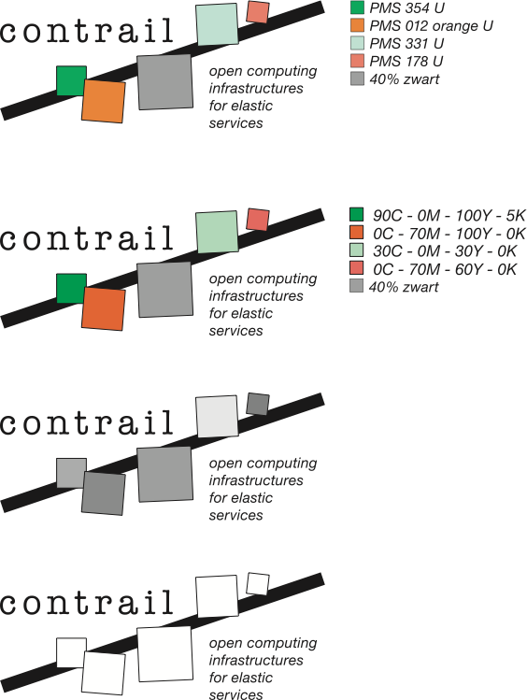
Open computing infrastructures for elastic services is the ultimate goal for the Contrail Project. The prospect of considerable economic benefits for business in Europe has motivated the European Commission to grant the project the amount of more than eight million Euro on a total project costing twelve million Euro. It’s one of the biggest projects in the European Seventh Framework Program and expected benefits are very exciting. Eleven organisation from six EU-countries are collaborating in the project that will tackle many prevailing cloud-issues like security, service level agreements or resource management. Contrail aims to perfect the existing cloud market by converging all suppliers in one homogeneous federated Cloud without any vendor lock-in.
Press release
Rennes (FR), January 24, 2011

What seems simple is, in fact, a huge challenge. Suppliers and users of computer capacity already have fast internet connections. But in future, systems will have to communicate seamlessly with one another, despite running different software on various platforms. The workload has to be distributed proportionally, data must be available to the owners and be totally secured at all times. Accesibility and interoperability are both of great importance. The project will run for a period of three years and will show tangible results:
1. Contrail will provide a complete Cloud platform which integrates a full Infrastructure-as-a-Service and Platform-as-a-Service offer.
2. Contrail will allow Cloud providers to seamlessly integrate resources from other Clouds with their own infrastructure.
3. Contrail will allow users to avoid the current lock-in situation by enabling live application migration from one Cloud to another.
- Contrail will be fully available in open-source.

Contrail has a budget of € 11,29 million. It will recieve € 8.3 million funding from the EC. In the first three months, the architecture and security model to be used in Contrail have been detailed.

The portal is available at http://contrail-project.eu

Note for the editors:
For additional information on this release you can contact Genias Benelux, mr. Ad Emmen: emmen@genias.nl or +31 6 5362 2098.
GEN_pb rennes110119 eng

